Patient Pathway Plus
Reduce cost, generate and or safeguard income, increase RTT performance and increase throughput

Using PP+ in a dynamic operational management setting revolutionises the way in which the elective care pathway to treatment is handled. Don’t look back, look forward.

A simple two-stage approach:

Stage one: PP+ has been proven to increase productivity and reduce cost whilst quickly eliminating invalid pathways on your waiting list. RTT performance can be affected by up to 5% simply due to poor quality data and invalid pathways. Fixing this is achievable via automated intelligent data quality and pathway validation

PP+ ensures that only valid pathways exist on the live waiting list. PP+ interfaces with your PAS and automatically builds pathways based on local and national standards flagging up potential DQ issues and invalid pathways.

The administrative burden of this process cannot be underestimated. Some organisations pay hundreds of thousands of pounds on both internal and external resource to manage this process.

PP+ removes a great deal of this burden as evidenced in this testimonial from Hull & East Yorkshire

"Let’s look at the first 5 weeks of using Patient Pathway Plus. On 18th December 2015, we started rolling out Patient Pathway Plus to a broad set of users. By 3rd February 2016, 27,051 validation actions had been recorded. Now let’s look at those 27,051 validation actions in context. We would expect a good external validator to complete 60 validations per day, provided he or she knew our local systems and processes and had a focused set of pathways to validate. Taking this as a guide, validating those 27,051 pathways would take a single validator 450 days. It would take 15 validators to validate those 27,051 pathways within that same time period. I’d estimate the cost of those validators to be about £112,500."

"For HEYT, we simply weren’t able to incur that type of external cost. It’s empowering to see how cost-efficient Patient Pathway Plus has been in so short a period."

Louise Topliss, General Manager of Performance, Hull and East Yorkshire Hospitals NHS Trust
Above is an extract from the following interview:
http://blog.insource.co.uk/hull-east-yorkshire-hospital-nhs-trust-setting-records-in-rtt

Once you are confident that you are looking at an accurate reading of your waiting list you can now use PP+’s powerful workflow capability to appropriately manage the operational and administrative tasks required to successfully process patients through to treatment within 18 weeks.

Stage two: Intelligent use of data and workflow capability will

PP+ provides a daily dynamic waiting and TCI list by patient, consultant and speciality. Triangulating this data with other key data sources such as consultant job plans, theatre capacity and utilisation, bed occupancy etc will transform the way Trusts manage waiting lists. This transparent and holistic approach will allow clinicians and managers to intelligently manage and prioritise activity resulting in increased throughput releasing pressures.

Throughout this process Patient Pathway Plus will fully support all the day-to-day operational activity associated with effective patient pathway management, all supported by accurate information for sustainable improvement. This is illustrated below:

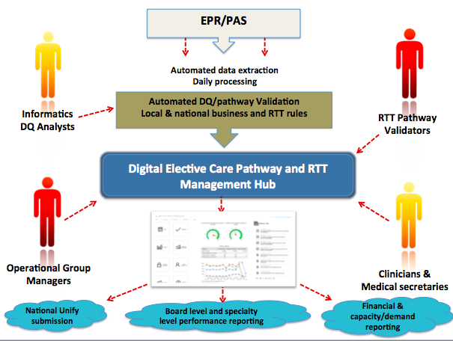

"We went from aggregate performance of -7% to +6% in just 5 weeks of using Patient Pathway Plus. Our productivity increased so much that in just 5 weeks we recovered a performance drop sustained over a 3-month period.”

- Proven to increase the productivity and reduce the cost of the entire RTT and elective care pathway management process
- For organisations not on block contracts it will help generate additional income
- For organisations who are faced with financial penalties the system will either help you meet targets or qualify and evidence issues around capacity and demand should you miss those targets
- Intelligently managing waiting lists will increase throughput and reduce waiting times
- Supports the STP agenda by allowing partner organisations to provide open access and visibility of waiting lists. Doing so will allow organisations to proactively share activity in times of need in order to release pressures

