Comprehensive traceability system for cytotoxic administration
- Queralt Gorgas Torner, M. Carmen Frías López y Víctor de Pedro Ambrosio. Servicio de Farmacia. Corporación Sanitaria Parc Taulí de Sabadell.
Josefa Ramírez Vaca y Mercè Mesalles Sin. Unidad de Enfermería. Hospital de Día de Oncohematología. Corporación Sanitaria Parc Taulí de Sabadell.
Introduction
Clinical advances in oncology and hematology have resulted in an exponential increase in the volume of patients receiving oncohematological treatments. The day hospital of oncohematology [Out-Patients] (HDOH) allows the administration of complex treatments that avoid hospitalizations, improve the quality of life of patients, speed up the care process and allow the provision of health to large populations.
The increase in the care activity in the HDOH predisposes to a special vulnerability to errors in the therapeutic process. Also, the increasing incorporation of therapeutic novelties implies a continuous change in the clinical, pharmaceutical and nursing practices, fact that causes that the situations that can cause errors in the preparation and administration of cytostatic drugs increase.
The process of care for oncohematological patients in a day hospital regime integrates admission programming, prescription and pharmaceutical validation, admission, preparation of doses of treatments to be administered, dispensing in a day hospital, administration of medication and its hospital follow-up, the discharge of the patient and its subsequent ambulatory follow-up.
Chemotherapeutic treatments are often drugs with narrow therapeutic margins and high toxicity. Consequently, the Errors in the therapeutic process are potentially serious and may affect the prescription, the preparation2 or the administration of the drugs and cause injury or even death in extreme cases. Ensuring patient safety throughout the therapeutic process has been and is a concern in the oncohematological area. The administration process is considered an especially sensitive aspect, especially since the publication in the general press of errors due to overdoses of cytotoxics with fatal consequences, 6,7and the communication in the medical literature of successive observational studies that confirm the dimension epidemiological, clinical and economic aspects of the problem.
In 2008, the American organizations, the American Society of Clinical Oncology (ASCO) and the Society of Oncology Nurses (ONS), brought together doctors, pharmacists, nurses, social workers and those responsible for health administration to reach an agreement on a set of safety measures. standard and to minimize the risk of errors in the HDOH of adults. According to the therapeutic process these recommendations are grouped into: a) related to staffing, b) related to the planning of chemotherapy and prescription, c) relative to the preparation of medications, d) relative to the administration (administration of chemotherapy, education and patient consent) and e) related to the subsequent monitoring and evaluation.
With respect to the administration process, one of the proposed measures as more effective is the use of the reading of the bar code (CB) in the tracking of the traceability of the medication. As a clinical verification tool, the CB can be applied to the verification of the agreement between the identity of the patient, the medications prescribed by the doctor, the dose prepared, the administration team and the correct time and route of administration. This technology applied to the control of the dispensation has demonstrated a great efficiency in the reduction of errors. Thus, a reduction of 85% of dosing errors has been described after introducing the BC reading to the internal verification process in a 735-bed hospital pharmacy service (from 0.2% to 0.07). % of the doses dispensed) Applying the CB reading to the administration process, a 41% reduction in the error rate has been observed in this process (from 11.5% to 6.8%) and a 50.8% reduction in the rate of potential adverse effects of errors (from 3.1% to 1.6%). a Despite the clarity of these results, recent estimates show that only 2% 6% of US hospitals they are using the CB reading system to reduce medication administration errors.
Some Spanish hospitals have implemented different traceability systems in the preparation phases and also in the administration phase. All are based on the reading of the CB: in some pharmacy service the vials of the drugs are re-labelled with a CB, in others the CB EAN-13 that carries the outer packaging of the medication and, in some other hospital, the traceability has reached the administration phase in which the patient and the users identify themselves with a
Digital trace and medication with CB by using laptops.
The Parc Taulí de Sabadell Health Corporation,
recently installed an integrated traceability system that involves both the process of
prescription for cytotoxic preparation, with the LUG – Traza integrated system (an integrated traceability and hospital safety system) this is an innovative system providing quality control of the preparations, based on sequential gravimetric controls. The programmed verifications and the generation of auditable computer records allow to reduce the vulnerability to errors and guarantee the safety of the patient at all times.
Equally, it facilitates the logistics by allowing the CB of medicines to be read without re-labeling and optimizes the management of warehouses, lots, expiration dates and product remains.
As an extension of this process to later stages of care practice, it includes a quality control system that also entails the process of cytostatic administration in the Out-patients (HDOH) of the Health Corporation of Sabadell and, as a novelty, it is integrated with the previous processes in a system of comprehensive security with complete traceability.
The process consists of establishing a traceability system that follows the workflow (path) of a chemotherapeutic protocol from the prescription, validation and preparation to patient administration, all with a CB that relates the treatment protocol, the preparation and its administration.
The system provides us with a quality control that does not allow any error in the whole process since, if it were to occur, it would be intercepted by the system, which would prevent the process from continuing.
In this paper, we will describe the implementation of the administration module in the HDOH (Out-Patients).

Integral traceability system for cytotoxic administration
The objective is to implement a comprehensive traceability system so that it can be applied by the doctors and nursing teams of the HDOH, as well as, the pharmacists and technicians of the Pharmacy Service in order to guarantee patient safety and the quality of health services taking into account the complexity of the pathway in an environment of intense care activity. Before the development and implementation of the traceability system module in the cytostatic administration in the HDOH, in 2013 the Traceability System was implemented in the Pharmacy within the environment of preparation and dispensing of chemotherapy treatments. This system consists of a computer application with HL7 interfaces designed to draw down and share data to provide individual [patient] information for each step of the oncological treatment process. The system communicates to various sources of hospital information: the administrative databases (EPR) to obtain information about the programming (cycles) and patient identification, as well as to manage the billing of the medication by episode and patient; the computerized medical prescription program (PPMI) [e-Prescribing] to receive information on products and doses needing to be prepared for each patient and set the calendar; and the system of purchase and management [Stock management system] of pharmacy stocks to guarantee at all times an adequate availability of medicines and information on their expiration date. The products are located in different places (e.g., preparation area, refrigerator, pre-cabins area, etc.) and a master file with pharmaceutical information of 314 chemotherapy drugs is available that includes data for quality control by means of control gravimetric, such as the density of the medication, instructions for reconstitution and final dilution, as well as the cytostatic dose and the maximum cumulative dose recommended and the methods of administration, stability and expiration of the reconstituted solutions and the final product. In the preparation area of ​​the Pharmacy Service, the facilities were adapted to the interactive control system: vertical laminar flow cabinets were provided with a voice recognition system, bar code / data matrix readers, scales and printers for labels.

Administration in the HDOH
The identification of the treatment by univocal CB was implemented, intended for reading in the HDOH (Sabadell Parc Health Corporation) in the final phase of medication preparation. For its implementation, the installation of a computer terminal connected with the PPMI program to the LUG TRAZA system and the computerized medical record was required. The different points of administration were equipped with location identifications of medication (beds or armchairs, as appropriate) and administration teams (infusion pumps), identification codes were also assigned to each of the nursing professionals involved in the administration process and the necessary systems were prepared to generate identifying CBs of the patient. Likewise, a wireless system was installed, with controlled and protected access, to allow the connection in network of a series of reading devices of CB coupled to PDA devices (personal organizers) assigned to the nursing staff and intended for data entry, as well as the CB reading of the medication prepared in the Pharmacy Service and the identification of nursing staff, patient, location and administration team at the foot of the bed or armchair.

Description of the applied process
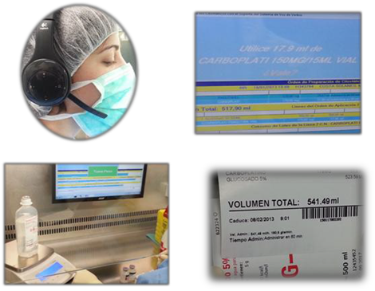
Figure 1. Stages of the preparation process
Preparation and dispensing
The process begins with the medical prescription; This is validated by the pharmacist. Subsequently, the information is translated into specific instructions, through an interactive voice system, which guide the pharmacy technicians in the process of preparing the medication dose. Throughout the preparation, gravimetric quality controls are carried out, by weighing the products at each step of the preparation and calculation of possible deviations from the weights calculated for the components used, which avoids preparation errors. The preparation process integrates the sequential preparation instructions, volumetric and gravimetric quality controls, and the automatic elaboration of individualized labelling with CB to guarantee the traceability of the dispensing. The complete treatment goes to quality control, generates labels of all the preparations and of the complete treatment, and is put in transport bags that will be sent to the HDOH. The entire process is recorded and documented.
Administration
In the HDOH the process is initiated by issuing a patient identification label that is incorporated into a card in which there are their demographic data and a CB in which the treatment is identified to guarantee agreement between the patient and the treatment prescribed by the patient, the oncologist or the hematologist. This card is personal and non-transferable, and the patient must carry it during the administration of all the cycles of the prescribed therapeutic scheme. In case of loss, another card can be generated.
The medication is received from the Pharmacy Service identified with the CB corresponding to the prescribed and prepared treatments; these
codes are recorded by reading the CB, after identification of the nursing professional by reading their identification CB. In this way, in the computer terminal of the HDOH, the correspondence of the patient's treatment with the electronic medical order is verified.
The system gives the instructions for the preparation, in the same HDOH, of antiemetic / adjuvant treatments and fluids for hydration according to the medical order that does not require specific preparation in the Pharmacy Service and generates the corresponding labeling.
At the point of administration, the nurse identifies with his/her code using the reader coupled to the PDA, also reads the patient's identification code and the code that identifies the location, as well as the identification code of the equipment or the perfusion pump. In the system, the treatment and the sequence of administration of the different medicines according to the prescribed cytotoxic scheme are indicated.
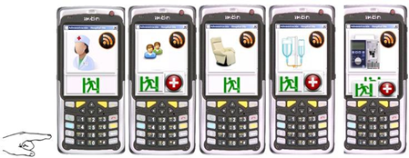
Figure 2. PDA, nurse identification, patient, cubicle, medication and infusion pump
The code of the therapeutic scheme of the patient is read and the administration of antiemetics / adjuvants is started followed by that of the first drug according to the order of the scheme. On each occasion, at the end of the administration of a medication, the CB is read again. The PDA screen informs of the drug to be administered next, which is confirmed by CB reading. When the administration is finished by reading the CB of the last
drug closes the process and the system releases the chair / cubicle and the administration equipment (infusion pump) to be used by the following patients (figure 3).
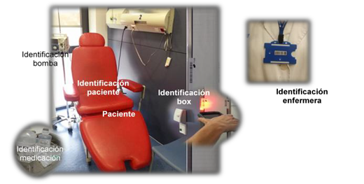
Figure 3. Traceability process: CB reading of the nurse administering the medication, the cubicle, the patient, the treatment and the perfusion pump
A detailed surveillance is carried out by active traceability of the entire process, so that, if the system detects an error in any step due to conflict in the reading of the CB that signifies an uncertainty in the drug to be administered, between patients or in the sequence of administration, an alert is generated that does not allow continuation of the administration of the medication. In case of any incident (e.g., allergies, extravasations, etc.) the nurse can stop the administration of the medication and the process from the PDA screen by selecting the option "treatment / patient" and the cytotoxic which has produced the incidence. Likewise, the system allows the notification of incidences occurred during the administration of the medication (extravasation, allergic reaction, fever, hypertension, dyspnea, chest pain and others). From the HDOH and the Pharmacy Service you can check the status of each medication preparation at any time (figure 4).
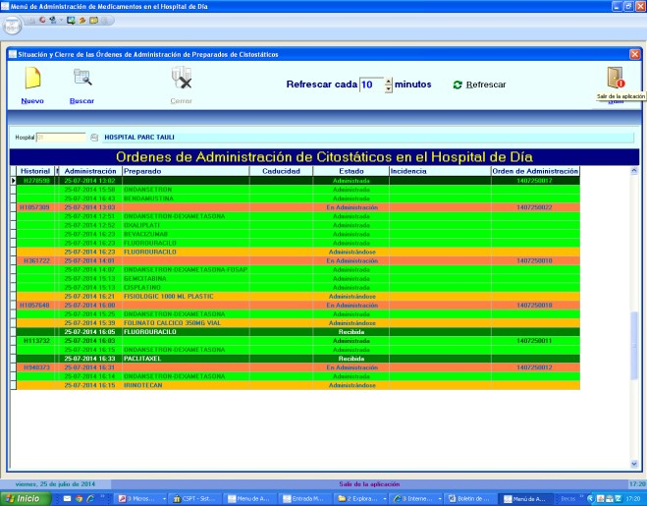
Figure 4. Monitoring of the administration of cytostatic preparations
Finally, the entire process initiated from the prescription is recorded and documented in an integrated manner and the batch of medication per patient can be drawn up for the application of safety measures against alerts from the manufacturer or the health authorities (passive traceability). It also facilitates the logistics given that the system allows to read the CB of the drugs without re-labelling and optimizes the management of warehouses, lots, expirations and product remains. The process has been integrated into the ISO accreditation environment of the HDOH Pharmacy Service, which, in turn, has generated a series of quality indicators of healthcare activity. The information and process integration scheme is shown in figure 5.
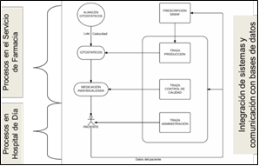
Figure 5. Integration of information and processes

Assistance results
Currently, 91.67% of the treatments administered are controlled from the beginning to the end by this integral traceability system. The activity of the integral traceability system (LUG TRAZA) from the period of February 19, 2013 to April 30, 2014 has been:
No. of treatments administered | 6,686
No. of preparations administered (cytotoxic) | 22,598
No. of preparations of antiemetics and adjuvants | 12,784
Traceability reports
PREPARATION | % of errors
Erroneous drugs intercepted in preparation | 0.013%
Wrong lot | 0.5%
Preparations detected with incorrect weight | 4.7%
Rejected preparations in weight control | 0.4%
ADMINISTRATION
ADMINISTRATION | % of Errors
Wrong patient | 0.027%
Wrong antiemetic | 0.04%
Wrong administration order | 0.11%
Conclusions
1. The (LG – Traza) integral traceability system allows a high degree of monitoring and control of the therapeutic process and improves the guarantees of patient safety and the quality of health services, through active traceability, alerting of errors in real time, and passive traceability, which allows effective implementation of security measures indicated by third parties.
2. The analysis of the guidelines and the predetermination of the different steps that must be followed in each of the phases reduces the potential for human error in a complex process and vulnerable to errors of potentially serious clinical consequences.
3. The system has elements of simple and intuitive use, fact that allows users to learn its operation easily.
4. This system is applicable in the future in other areas (other day hospitals, parenteral nutrition, master formulation) of clinical activity of recognized therapeutic complexity.
Bibliographic references
1. Jurek T, Rorat M, Dys P, Swiatek B. Fatal cisplatin overdose in the treatment of mediastinal lymphoma with the ESHAP regimen - analysis of the causes of the adverse drug event. Onkologie 2013;36(1-2):49-52.
2. White R, Cassano-Piché A, Fields A et al. Intravenous chemotherapy preparation errors: patient safety risks identified in a pan-Canadian exploratory study. J Oncol Pharm Pract. 2014;20(1):40-6.
3. Bauters T, De Porre J, Janssens N. Prevention of wrong route errors in a pediatric hemato-oncology ward. Pharm World Sci 2009;31(5):522-4.
4. Bauters T, De Porre J, Janssens N. Prevention of wrong route errors in a pediatric hemato-oncology ward. Pharm World Sci 2009;31(5):522-4.
5. Kullberg A, Larsen J, Sharp L.'Why is there another person's name on my infusion bag?' Patient safety in chemotherapy care - a review of the literature. Eur J Oncol Nurs. 2013 Apr;17(2):228-35.
6. Kolata G. Cancer Drug Overdoses: Rare but Deadly. The New York Times, March 24, 1995.
7. Tavernise S. Overdose Deaths Continue to Climb. The New York Times, February 19, 2013.
8. Watts RG, Parsons K. Chemotherapy medication errors in a pediatric cancer treatment center: prospective characterization of error types and frequency and development of a quality improvement initiative to lower the error rate. Pediatr Blood Cancer 2013;60(8):1320-4.
9. Aita M, Belvedere O, De Carlo E, et al. Chemotherapy prescribing errors: an observational study on the role of information technology and computerized physician order entry systems. BMC Health Serv Res 2013;13:522.
10. Walsh KE, Dodd KS, Seetharaman K, et al. Medication errors among young adults and children with cancer in the outpatient setting. J Clin Oncol 2009;27:891-6.
11. Gandhi TK, Bartel SB, Shulman LN, et al. Medication safety in the ambulatory chemotherapy setting. Cancer 2005;104:2477-83.
12. Leon Villar J, Aranda García A, Tobaruela Soto M, Iranzo Fernández MD. Errores asociados con la prescripción, validación, preparación y administración de medicamentos citostáticos. Farm Hosp. 2008; 32 (3):163-9.
13. Ranchon F, Salles G, Späth HM et al. Chemotherapeutic errors in hospitalised cancer patients: attributable damage and extra costs. BMC Cancer. 2011 Nov 8;11:478.
14. Jacobson JO, Polovich M, McNiff KK, et al. American Society of Clinical Oncology/Oncology Nursing Society chemotherapy administration safety standards. Oncol Nurs Forum 2009;36(6):651-8.
15. ASHP. Statement on bar-code enabled medication administration technology. Am J Health Syst Pharm. 2009;66(6):588-90.
16. Poon EG, Cina JL, Churchill WW, et al. Effect of Bar- code Technology on the Incidence of Medication Dispensing Errors and Potential Adverse Drug Events in a Hospital Pharmacy. AMIA Annu Symp Proc. 2005; 2005:1085.
17. Poon EG, Cina JL, Churchill W, Patel N, Featherstone E, Rothschild JM, et al. Medication dispensing errors and potencial adverse drug events before and after implementing bar code technology in the pharmacy. Ann Intern Med. 2006;145(6):426- 34.
18. Poon EG, Keohane CA, Yoon CS, Ditmore M, Bane A, Levtzion-korach O, et al. Effect of bar-code technology on the safety of medication administration. N Engl J Med 2010;362 (18):1698-707.
19. Patient Safety and Quality Healthcare, Improving Medication Safety with a Wireless, Mobile Barcode System in Community Hospita, l May/June 2005. Pérez Ricart A, Mestre Galofré L, Farriols Danés A, Carreras Soler MJ, Renedo Miró B, Martínez Cutillas J. Servicio de Farmacia Hospital Universitario Vall d’Hebron, Barcelona, Control de producción cualitativo-cuantitativo y trazabilidad en la preparación de citostáticos. 58º Congreso Nacional de la Sociedad Española de Farmacia Hospitalaria y Encuentro Iberamericano de Farmacéuticos de Hospital. Málaga, Octubre 2013
20. Farriols A, Carreras MJ. Safety in the cytostatic preparation process: traceability and control. Newsletter for the prevention of medication errors in Catalonia 2013; 11 (3). Accessed on 05/29/2014 at: http://www20.gencat.cat/docs/canalsalut/Minisite/Medicament s / Professionals / 6_Recursos / Butlletins / Butlleti_Errors_Medicacio/Documents/Archives/BEM_v11_n3.pdf
21. Anonymous. News from the University Hospital La Paz, 02/15/2010. La Paz implements bar codes and improves the administration of oncology drugs. Posted on 05/29/2014 in:
http://www.madrid.org/cs/Satellite?cid=1142581621979&language=es&pageid=1142683383647&pagename=HospitalLaPaz%2FCM_Actualidad_FA%2FHPAZ_actualidad).
22. Creus N. Traceability and quality control of the preparation and administration of chemotherapy, 55 National Congress of the Spanish Society of Hospital Pharmacy. October 2010.
23. Cajaraville G. Process of the use of Cytostatic medications. I Course on New Technologies applied to the Pharmacy Service. Module 3. May 2011.
24. By Pedro Ambrosio V, Frías López MC. Safety from the reception to the administration of cytotoxic and clinical trials through an automated comprehensive traceability system. Hospital Parc Taulí, Sabadell. 58th National Congress of the Spanish Society of Hospital Pharmacy and Iberoamerican Meeting of Hospital Pharmacists. Malaga, October 2013

