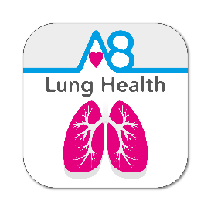

SENSOR 3:

Reducing hospital readmissions for COPD exacerbations by using self-monitoring to educate, empower and engage patients to better self-manage.

Introduction to the SENSOR project

The Concept of Self-Care in COPD vs. Remote Monitoring

Self-Care combined with technology used to measure and record vital signs and symptom scores at home, is a cornerstone of the 5-Year-Forward-View to allow patients to manage their long-term conditions (LTCs) and associated symptoms more effectively at home.
Those patients that are still well enough and competent to manage Self-Care, need to recognise exacerbations symptoms at an early stage, seek medical attention earlier during the therapeutic window, before an exacerbation causes further loss of lung function which can be irrecoverable.
Stages of Chronic Obstructive Pulmonary Disease (COPD) have been divided into 4 “Grades” by the Global Initiative for Chronic Obstructive Lung Disease (GOLD). The latest report on COPD for 2017 has been published (Download here: http://goldcopd.org/gold-2017-global-strategy-diagnosis-management-prevention-copd/)
The GOLD Grades have now been reclassified to take into account both lung function and now exacerbation history.
Two or more exacerbations requiring hospitalisations in 12 months now place a patient, irrespective of remaining lung function, into GOLD D, while the GOLD number (1-4) indicates reduction in Lung Function.
So a patient with a GOLD GRADE of 4D is the most severely ill and has lung function below 30% FEV1 of predicted (for age, gender, height, ethnicity etc.) and has been admitted twice in the previous 12 months.
The severity of symptoms is now defined by the COPD Assessment Test (CAT) score, comprising of similar questions to those used in the Aseptika Lung Health3 App (Wellness, Cough Severity, Energy, Breathing difficulty and Appetite). The inter relationship of these characterisations is described below (Fig. 1).

Fig. 1. GOLD Assessment of patient with COPD taken from the GOLD 2017 report and copyrighted to GOLD.

The greatest loss of lung function in COPD takes place in GOLD Grades 1-2, with over 60% of lung function being lost either before diagnosis or shortly after (Fig 2).

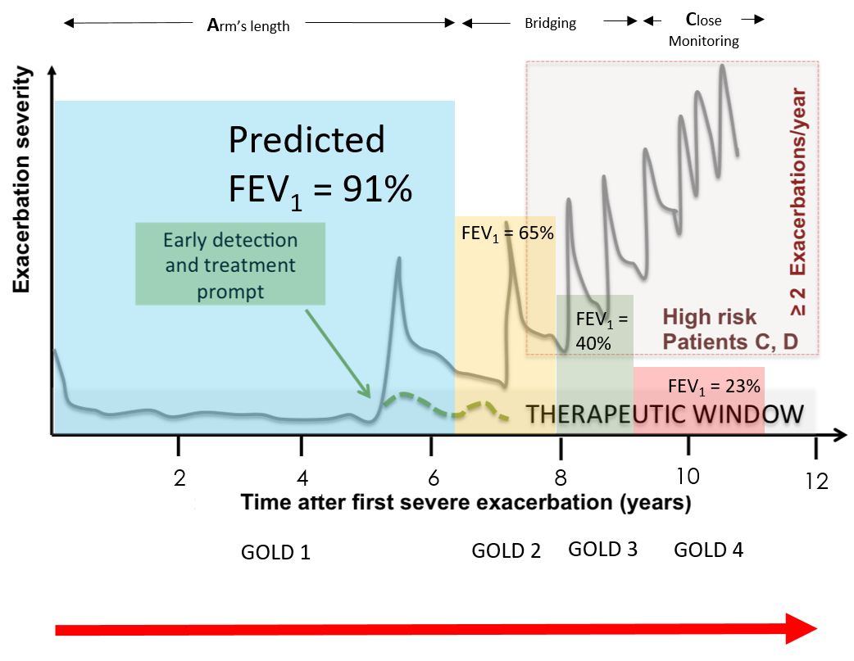
Fig 2. Decline in lung function (GOLD 1-4) with time and increase in severity of symptoms (A-D) with time. Lung Function decline from Dransfield et al Am J Respir Crit Care Med. 2016 Aug 24.

There is little support for COPD patients during the early part of their disease pathway in which the greatest loss of lung function occurs (GOLD 1- 2).
Traditional self-management includes education to be used in conjunction with proven treatments such as smoking cessation and pulmonary rehabilitation (PR).
An innovative approach is required.

The SENSOR 3 Project Concept
Activ8rlives and its themed version for patients with COPD called Lung Health3 is being used in the SENSOR 3 project by helping patients to record vital signs and symptoms using connected CE-marked medical monitors and smart devices such as Smartphones and Tablets, which display the results to the patient and also upload these data to the Activ8rlives cloud (hosted by UKCloud, Farnborough UK). www.activ8rlives.com.
Using a step-by-step picture-based interface (see appendix 1) patients record 41 parameters of health and vital signs. Data is displayed as simple charts to enable improved patient understanding. The whole process takes the patient approximately 12 minutes each day, with no involvement from Health Care Workers (HCWs).
Data collected includes: subjective health scores such as appetite, fatigue, cough, also, contact with HCWs, use of rescue antibiotics/steroids, hospitalisation, in addition to vital signs SpO₂, Peak Flow, FEV₁, Temperature, Heart Rate and Blood Pressure, weight and physical activity.
HCWs may access patient-generated data via a web-portal allowing patients to be remotely “mentored.” This can be used in two modes: Self-Care with no (or intermittent) remote monitoring, or in full telehealth mode with daily monitoring by a HCW.
Our concept was to use Self-Care alongside current clinical and community services. The patient becomes an unpaid collector of data for us and educated in the interpretation of their own values and encouraged to act promptly on this information thus receiving appropriate treatment earlier than previously and potentially mitigate avoidable hospital admissions.

The primary objectives of the project were:
- To assess whether providing the Lung Health 3 solution for 20 patients with LTRCs which meet the selection/inclusion criteria, can reduce the number of avoidable hospital admissions and readmissions compared with the pre-interventional stage
- To compare the number of rapid response contacts before and after the intervention with Lung Health3 solution
- To evaluate the time-scale between the intervention with Lung Health3 solution and the first respiratory exacerbation that leads to a hospital admission
- Undertake health economics to understand where in the COPD progression map (British Lung Foundation) the potential cost benefits of prescribing the Lung Health3 solution outweigh the savings generated by saving bed days
- To report and create evidence of the outcomes so as to support a larger-scale roll-out of Lung Health3

The secondary objectives were:
- Quantitatively assess whether Lung Health3 can be used by our patients to successfully self-monitor, many of the key vital signs (Blood Pressure, Heart Rate, Temperature, Oxygen Saturation) and other parameters of wellbeing (physical activity levels, weight/body composition, lung function) as measured by adherence rates by day
- Qualitatively assess the perception of patients and their carers whether they consider the quality of the service we provide has changed through the addition of Lung Health3 to their care as measured with satisfaction questionnaires
- Qualitatively assess the patient’s perception of quality of life (QOL) at the end of the study
- Qualitative assess the patient’s anxiety and depression levels following implementation of Lung Health3 using Hospital Anxiety & Depression Scores.
- Measure the difference in time lapse between onset of symptoms/change in vital signs to the point of initiation of self-care as indicated by starting antibiotics
- The relationship between time lag to initiation of self-care treatment and the number of admission spells
- Qualitatively assess the perception of clinical / social care staff as to whether they believe the level of care being provided has changed
- Generate a full understanding of hospital bed day cost to support future health economic extrapolations.

Demographics of selected cohort
The average age of the sample is 69 yrs. of age. One patient was just 42 when commencing the study and while meeting the requirements of having 2 hospitalisations in the prior 12 months is atypical and while doing very well stepped-down to self-care. (He has since engaged a personal training, reduced weight and increased physical activity) is not typical of the majority of patients. The demographics of the cohort are:
- All had at least 2 hospital admissions (
- Number males: 6 Number female: 10
- Average predicted FEV1:53%
- GOLD status: majority ‘D’. (2 B)
- Number of palliative patients: 6
- Previous telehealth patients: 4
- Mean age: 66

Implementation
The Activ8rlives system was provided to 15 patient’s March 2016. Implementation, start-up and training, took approximately 90 minutes per visit and included adding the IPad provided to patient’s home Wi-Fi. A further 3 was installed in July, August and December 2016. The equipment was installed into the patients’ homes by a member of the Knowlsey COPD team and the MD Aseptika. Introduction to equipment, a demonstration on how to use the equipment was discussed at length. In addition health indicators were discussed with the patients in a narrative of what signs and/or symptoms of an exacerbation, patients were expected to be aware of.
Patients were provided with the rapid response contact details and encouraged to contact the service as usual should their measurements indicate to and their symptoms decline.
Patients were advised that this is a self-management system and required them to interpret their own data and act accordingly.
They were provided with a User-Guide.
Approximately 4 months after the project began it become apparent that patients were unable to judge whether or not to contact the Knowsley Community Respiratory Response Service. Consequently, it was identified that further education of identifying early warning signs was required and an education booklet was produced in response to this ‘Know your Numbers’ and was sent to all patients.
Following feedback from the patients, in particular those with very severe COPD and poor functional capacity, the order in which patient collected the data resulted in patients weighing themselves mid-way through. This impacted on the resting heart rate and oxygen levels and consequently patients were unable to identify or compare resting states with resting states. Therefore the sequence now reflects this feedback with body weight being collected at the end of the routine. In addition, and in conjunction with the ‘Know your Numbers’ booklet a ‘rest, relax and re-check’ mantra was introduced.
Also following feedback from the patients the display of charts also changed to assist with patient’s interpretation of the data. Originally displaying several line graphs overlapping proved too difficult for patients to interpret and understand therefore the data is now presented in individual bar charts and line graphs showing each piece of data in much friendly and easy to read charts, as displayed in Fig.3 & 4.
In addition, for these very frail, high risk patients, a large amount of time was spent remotely monitoring individual readings and prompting patients to act accordingly, reinforcing and educating patients on self-management skills

Outcome Measures & Discussion
At time of writing, information is not available for the admissions history of patients selected for this feasibility study before their inclusion in the trial, only that they fulfilled the inclusion criteria of having at least 2 admissions in the previous 12 months. During the study, we could track admissions, alerts and correlation of symptoms and vital signs with calls to the rapid response line and hospital admissions to LHCH. We intend to collect these data relating to pre-trial in the coming months but this is confounded by the difficulty in collecting these data in a region in which there are 4 separate hospitals. During the study, patients would go “missing” and would stop recording. Subsequently we found that they had been admitted to other hospitals and there was no way to track this.
There was an unrealistic expectation that providing Technically-Enabled Self-Care would halt admissions. Out of the 16 patients recruited onto the study four were on the palliative register prior to beginning the sensor3 project, a further three were subsequently identified as being palliative during the 12 months trial. . Our conclusion is that this High-risk group is too far progressed in their disease pathway to be stepped-down to Self-Care from Tele-health to self-monitoring.
We intend to explore how much time per day it took each patients to complete the routine and also to see if the improved over time.
We intend to explore if activity levels increased hypothesising that daily monitoring activity levels via a buddy band would improve awareness of activity and potentially motivation.
Compliance rate at the time of writing is approx. 65%.
Since March 2016 five patients have dropped out. Also, one patient died post lung transplant.
The reasons provided by the patients that dropped out are:
- Equipment not being suffice i.e. blood pressure cuff too large or small.
- Lack of IT skills and family help
- Preferring the constant monitoring of Tele-health
- Mental health issues
- Buffering issues / frustration at equipment not working

Predicting Exacerbation
The trial at LHCH was the first time the Company provided direct feedback and alerts of impending exacerbation to a clinical team. This was not the anticipated approach, but delays in getting protected time for the LHCH project manager and lack of engagement by the Community Respiratory Team meant there were no resources to undertake daily review of these patients, given the severity and complexity of their conditions and that some had been stepped-down from daily monitoring (telehealth) to self-monitoring and were perhaps, too frail to cope with this withdrawal of support, having become dependent on it.
The small sample number, lack of baseline data on hospitalisation prior to starting the trial makes conclusive statements about any reduction in hospitalisation challenging, but we can make the following observations thus far:
- Patients in GOLD 3 tend to adhere and stay with self-monitoring and have become very good at operating the system and have learned to interpret their results. A good example shown in Fig. 3

- Patients in GOLD 4 quickly abandoned monitoring after their next hospitalisation, perhaps losing confidence or realising that there was “no one looking out for them” despite being aware this was self-monitoring. Fig 4 demonstrates a patient who had previously used telehealth.

- Exacerbations for some patients can be predicted 5-7 days before the patient begins self-medication with rescue packs, because the decline in PEF/FEV1, SpO₂ and step count (physical activity) are very dramatic for Patients in GOLD Grade 3. For Patients in GOLD 4, their values are so low that it is hard to distinguish a “bad day” from a “good day” and even their subjective wellness scores do not reflect changes in their symptoms.

- Even giving the Community Response Team 3-4 days’ notice does not prevent hospitalisation for many patients as some patients require IV medication not available in the community and therefore a hospital admission is necessary.

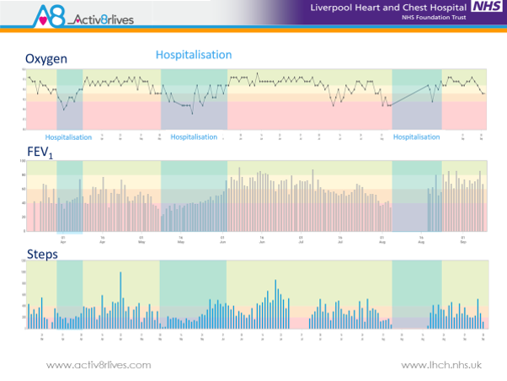
Fig.3. Male patient, GOLD 3D, showing the interconnection of blood oxygen, %prediction of FEV₁, and step count. This patient is now able to determine when his lungs are becoming obstructed with mucus and seeks help earlier, but a hospital procedure (bronchoscopy) to remove the mucus from his lungs is still required (and brings immediate recover of lung function and physical activity achievable as a result). But has not removed the need for hospital-based treatment.
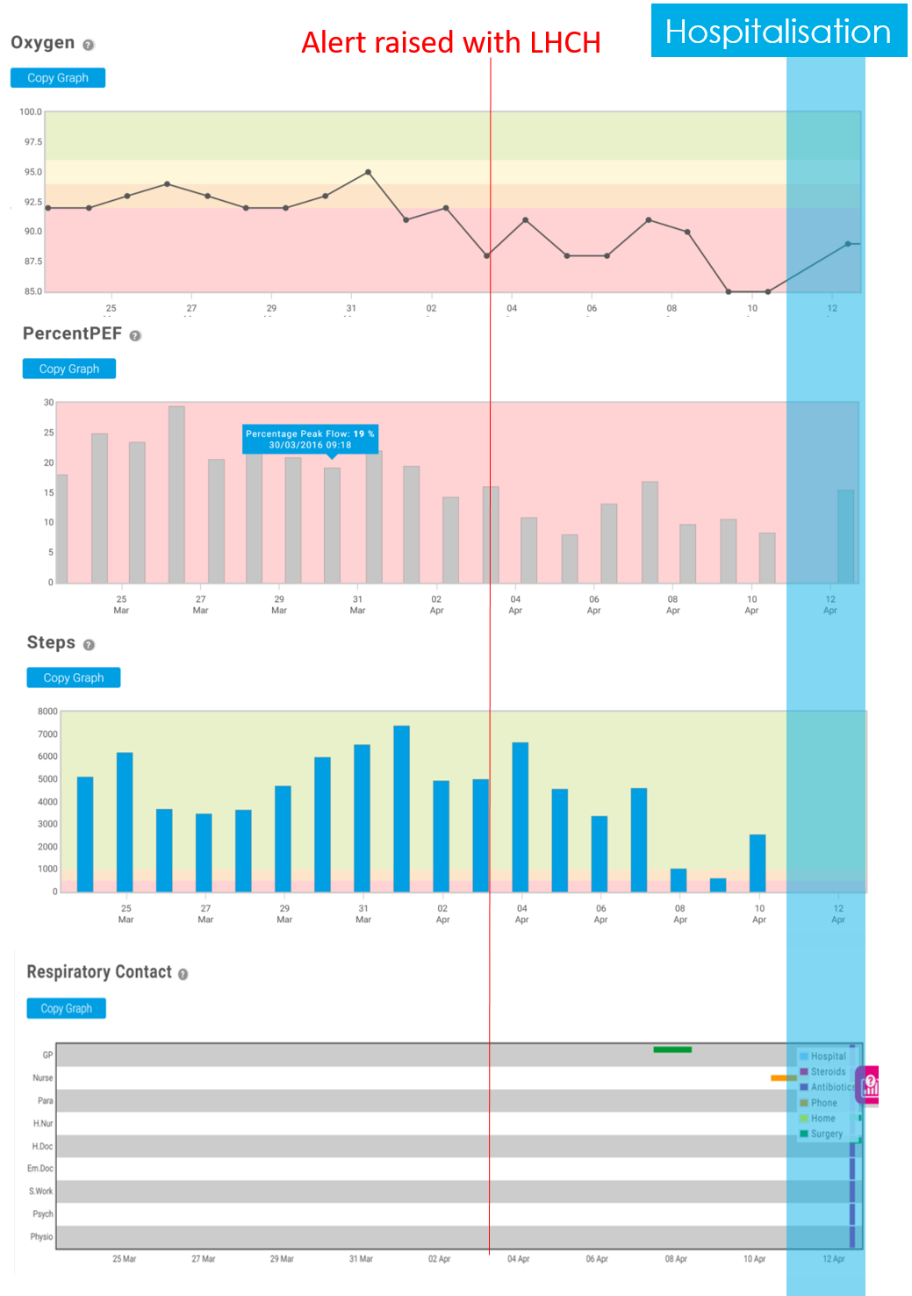
Fig. 4. Data recorded by a High-Risk patient at GOLD Grade 4 D. Note the low %FEV1, rapid desaturation and declining step count. The alert was raised 7 days ahead of hospitalisation but even with advanced warning and treatment at home, hospitalisation was the outcome for this frail female patient who lived alone.

Learning to date

The patients recruited onto this study were, for the most part, too far progressed in their disease pathway to benefit from Technology-Enabled Self-Care (TESC) that was being provided. Patients we selected on the basis of having two or more hospital admissions in past 12 months and therefore represented were “high users of services”. Those with GOLD Grades of 1-3 would benefit from TESC, but for those with GOLD Grades 3-4 group D, we surmise it is already too late.
Further, the team has learned that for technology to improve outcomes, we propose the patient cohort must be stratified, stepping-up the level of intervention as the patient progresses from LOW-risk, to RISING-risk to High-risk patient groups. In order to technology to help at all, a telemedicine solution is required in which nurse-level staff monitor on a daily basis, the changes in vital signs and symptom scores recorded at home by the patient or with support of family members is too frail. See Fig 3.
TESC with no routine monitoring (or infrequent monitoring e.g. at routine Outpatient Reviews) can best be applied at what is termed the RISING-risk cohort. These will become the High-risk group of the future unless an intervention is made. Typically, this group has suffered their first exacerbation (whether hospitalised or not) and are often referred to Pulmonary Rehabilitation. The Company’s view is that this is where the Activ8rlives self-care solution should now be deployed based on its experiences at LHCH to “left-shift” or halt the decline of the RISING-risk into the High-risk group using education, exercise and empowerment to up-skill patients before them become too frail and dependent on more expensive hospital-based services.
Other insights gained with surveys taken at midway point of our volunteers:
- 65% patients are compliant with the technology
- 90% patients are satisfied with the technology
- 80% patient are competent using the technology after just 4 weeks
- 85% patients would recommend this technology of self-monitoring to a fellow patient
- 60% patients are happy to contribute financially to the technology to improve self-management – quite a surprise given the low income per house-hold in the Knowsley district.

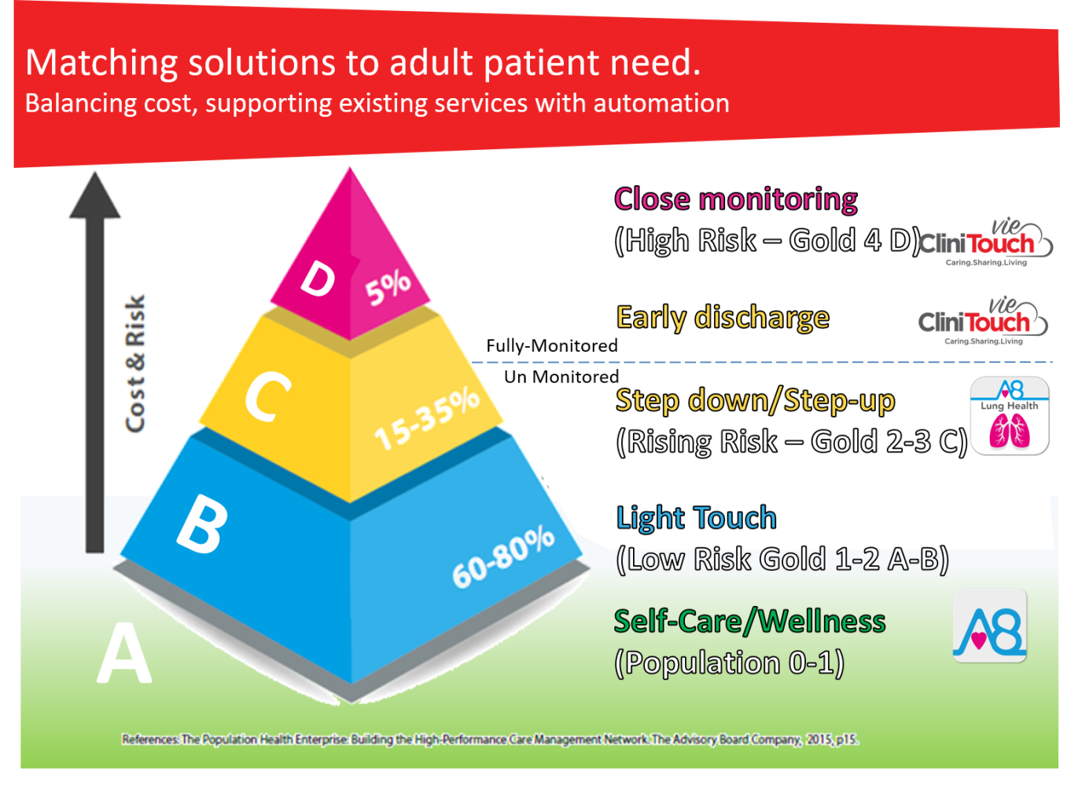
Fig. 5. Cascade of severity of COPD GOLD Grades 1-4 and A-D matched to the continuum of technologies now provided by Spirit Healthcare (of which Aseptika is now an integral part). Spirit is a UK SME with its headquarters in Leicester.

APPENDIX 1: Equipment provided to COPD patients.

